Timmy Pollard-Grayson
Danny Debs
Maverick Murphy
POE Block 2

2.1.9 Truss Design

Problem Statement
Criteria and Constraints
In this project, we were tasked to create a roof truss using balsa wood members, hot glue, and paper gussets. The truss had to hold a weight of at least 30lbs, but it also had to be constructed out of only 36 inches of balsa. The penalty for using over 36 inches was a point off per extra inch. The truss also had to fit inside of the apparatus, meaning it had to be wider than 6 ⅞ inches and taller than 4 ⅝ inches.

Test Truss
Credit to Daniel Afshar
Sketch of Test Truss, MDSolids, and SSA Graph
Efficiency
The formula for efficiency is $E=F/W$. The force our test truss took was 12 lbs, and the total weight of the test truss was 0.009375 lbs (0.15 oz). When plugged into the formula, we get that our efficiency was 1280%.
Conclusion
In conclusion, the test truss was successful, but we didn’t hold as much as we would have liked. The test proved that a truss with triangles was certainly efficient, so we added a lot of triangles to our final design.

Research

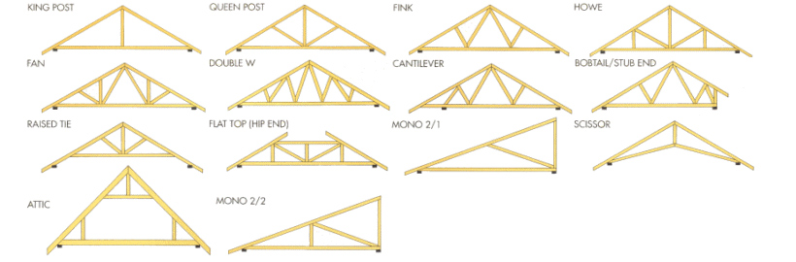
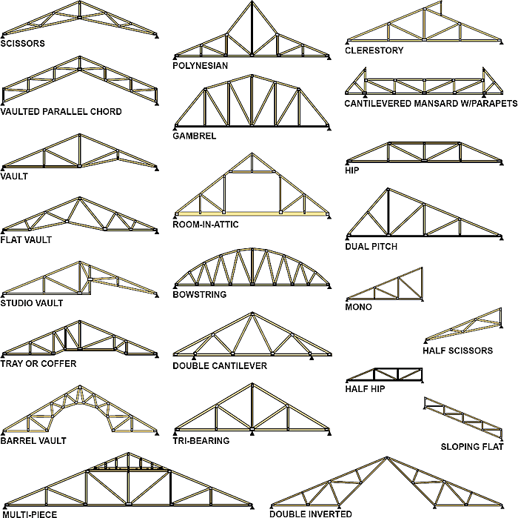

"Residential Roof and Floor Framing Systems, Part 2: Conventional Framing." The Inspector. N.p., n.d. Web. 01 Dec. 2015.
"Read Brothers Limited: Roof Truss Manufaturers in Norwich - Truss Images Page." Read Brothers Limited: Roof Truss Manufaturers in Norwich - Truss Images Page. N.p., n.d. Web. 01 Dec. 2015.

Research (cont.)
We consulted these two sources for our research. We looked at all of the pictures and modified a few that we liked. For instance, Maverick modified the “Double Cantilever” design and I modified the “Polynesian” design.

Design Idea

My idea was over the maximum 36 inches by 4 ¾ inches, so that would have taken out a good amount of points.
MDSolids Test
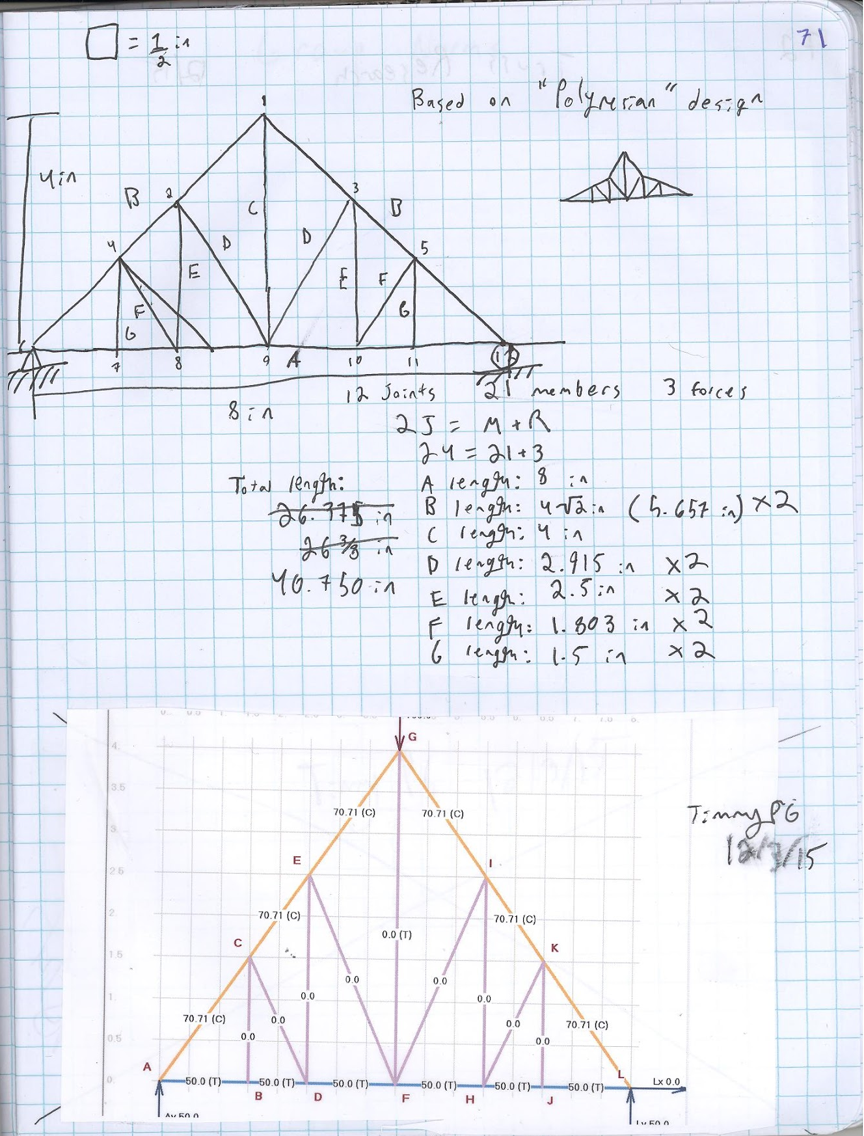

Decision Process
Team Member’s Ideas
Referring to the sources above, Maverick’s idea is a modified version of the “Double Cantilever” and Danny’s idea was similar to the “Room in Attic” Design, since it had a square with smaller triangles in it, but ultimately the truss was a triangle.
Decision Matrix 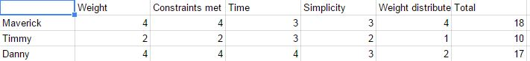
We decided to do these five categories and rate each design on a scale of 1-4. We chose these criteria so we would chose the most efficient design. In the end, we ultimately chose Maverick’s design, since it had the least amount of materials, was simplistic, and also did a good job of distributing weight. Unfortunately, Maverick’s design had a few problems that we overlooked, since we had miscalculated the total length and it had also been designed too tall. We ended up fixing both these problems in our final design, but they did cause areas of trouble for us during the build.
Chosen Idea Dimensioned Sketch

Official Test
Broken Truss
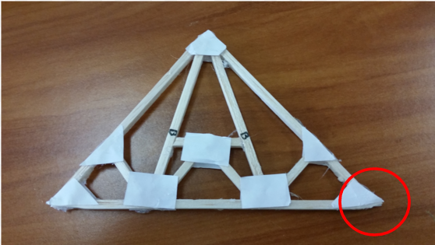
Ultimately, our truss only crushed at the corner, making it slip from the apparatus. None of the members actually broke, but it was able to hold 47 lbs.
SSA Graph and MDSolids
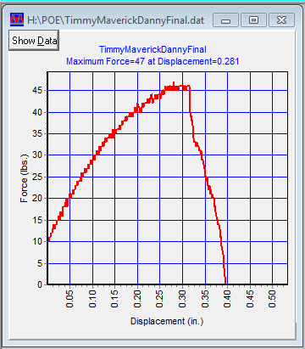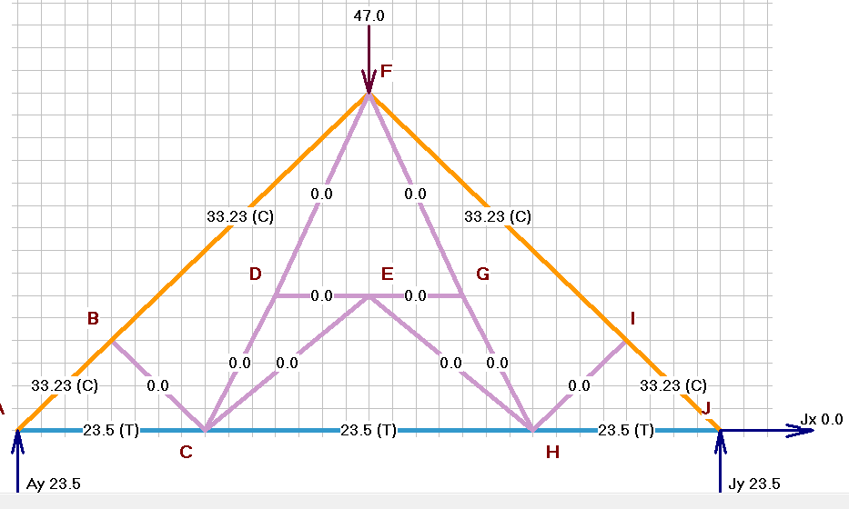
Efficiency

The formula for efficiency is $E=F/W$. The force our final truss took was 47 lbs, and the total weight of the test truss was 0.015625 lbs (0.25 oz). When plugged into the formula, we get that our efficiency was 300,800%.

Teamwork
Maverick
Maverick was absent for the build day, and so wasn’t able to complete his job as data-collector, but in the days beforehand he contributed greatly to the research and ideas. Overall, Maverick contributed well to the group and would have contributed more but was absent.

Danny
The first day of design, Danny was not working, not even at our table, and so he was behind for the first day, and we had to get him caught up. During the build day, he helped a lot, but wandered off several times. Overall, Danny contributed, but not as much as would be expected in a group project.

Me
I feel like I contributed as much as would be expected of me, since Maverick and I both contributed about the same before build day, but I did most of the construction since Danny kept wandering off. I also went in early to finish testing the truss, but neither Danny or Maverick could make it to that.

Reflection
I think that our truss broke where it did because it was too short, and so when placed on the circular supports, it slipped easier, and would have withstood more force if it were longer. If we ever did this project again, I would make it longer, and use less wood.

